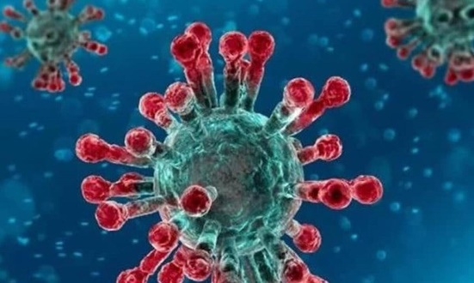
Σκέφτομαι και γράφω
Ήρθε ο καιρός να γράψουμε το ‘’Σκέφτομαι και γράφω ‘’χωρίς τις οδηγίες μου!!! Θυμόμαστε ό,τι έχουμε μάθει! Στο τέλος κάνουμε την αυτοαξιολόγησή μας!!

- Πρώτα διαβάζω τα 2 βιβλία από τα link…
http://users.sch.gr/cosmathan/covid-19/2dsl.html
http://users.sch.gr/cosmathan/covid-19-2/2dsl.html

«Τι είναι ο κορωνοϊος και πώς έχει επηρεάσει την ζωή μου;»
------------------------------------------------------------------------------------------------------------------------------------------------------------------------------------------------------------------------------------------------------------------------------------------------------------------------------------------------------------------------------------------------------------------------------------------------------------------------------------------------------------------------------------------------------------------------------------------------------------------------------------------------------------------------------------------------------------------------------------------------------------------------------------------------------------------------------------------------------------------------------------------------------------------------------------------------------------------------------------------------------------------------------------------------------------------------------------------------------------------------------------------------------------------------------------------------------------------------------------------------------------------------------------------------------------------------------------------------------------------------------------------------------------------------------------------------------------------------------------------------------------------------------------------------------------------------------------------------------------------------------------------------------------------------------------------------------------------------------------------------------------------------------------------------------------------------------------------------------------------------------------------------------------------------------------------------------------------------------------------------------------------------------------------------------------------------------------------------------------------------------------------------------------------------------------------------------------------------------------------------------------------------------------------------------------------------------------------------------------------------------------------------------------------------------------------------------------------------------------------------------------------------------------------------------------------------------------------------------------------------------------------------------------------------------------------------------------------------------------------------------------------------------------------------------------------------------------------------------------------------------------------------------------------------------------------------------------------------------------------------------------------------------------------------------------------------------------
------------------------------------------------------------------------------------------------------------------------------------------------------------------------------------------------------------------------------------------------------------------------------------------------------------------------------------------------------------------------------------------------------------------------------------------------------------------------------------------------------------------------------------------------------------------------------------------------------------------------------------------------------------------------------------------------------------------------------------------------------------------------------------------------------------------------------------------------------------------------------------------------------------------------------------------------------------------------------------------
-----------------------------------------------------------------------------------------------------------------------------------------------------------------------------------------------------------------------------------------------------------------------------------------------------------------------------------------------------------------------------------------------------------------------------------
-----------------------------------------------------------------------------------------------------------------------------------------------------------------------------------------------------------------------------------------------------------------------------------------------------------------------------------------------------------------------------------------------------------------------------------------------------------------------------------------------------------------------------------------------------------------------------------------------------------------------------------------------------------------------------------------------------------------------------------------------------------------------------------------------------------------------------------------------------------------------------------------------------------------------------------------------------------------------------------------------------------------------------------------------------------------------------------------------------------------------------------------------------------------------------------------------------------
Όνομα ………………………………………………………………………………………………..
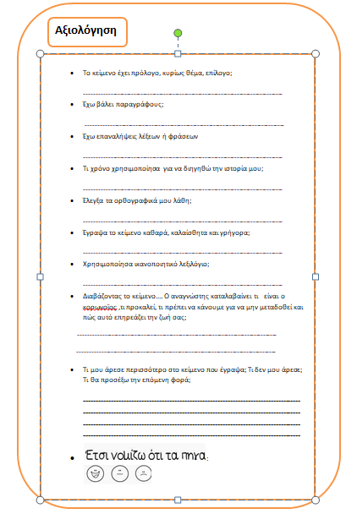κλ

